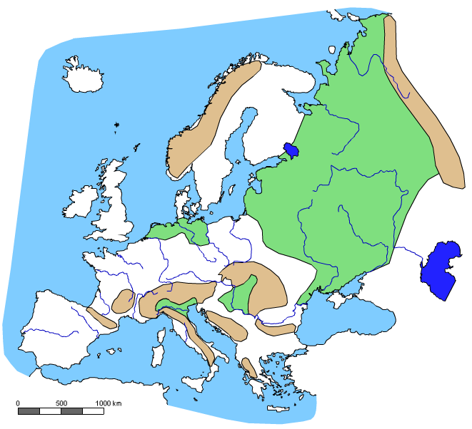

**4**

**16**

**15**

**14**

**13**

**12**

**11**

**10**

**9**

**8**

**7**

**6**

**5**

**3**

**2**

**1**

Pomenuj čísla na mape:

|  |  |  |
| --- | --- | --- |
| 1 |  | oceán |
| 2 |  | more |
| 3 |  | more |
| 4 |  | prieliv |
| 5 |  | záliv |
| 6 |  | ostrov |
| 7 |  | polostrov |
| 8 |  | ostrov |
| 9 |  | polostrov |
| 10 |  | nížina |
| 11 |  | pohorie |
| 12 |  | pohorie |
| 13 |  | nížina |
| 14 |  | rieka |
| 15 |  | rieka |
| 16 |  | jazero |



**7**

**9**

**15**

**14**

**12**

**11**

**13**

**10**

**8**

**6**

**5**

**4**

**3**

**2**

**1**

**16**

Pomenuj čísla na mape:

|  |  |  |
| --- | --- | --- |
| 1 |  | oceán |
| 2 |  | more |
| 3 |  | more |
| 4 |  | prieliv |
| 5 |  | záliv |
| 6 |  | ostrov |
| 7 |  | polostrov |
| 8 |  | ostrov |
| 9 |  | polostrov |
| 10 |  | nížina |
| 11 |  | pohorie |
| 12 |  | pohorie |
| 13 |  | nížina |
| 14 |  | rieka |
| 15 |  | rieka |
| 16 |  | jazero |